Chapter 5

Microwave Communication systems

a) Block diagram and working principles of microwave communication link.
AND
b) Troposcatter Communication-basic idea

Block diagram and working principles of microwave communication

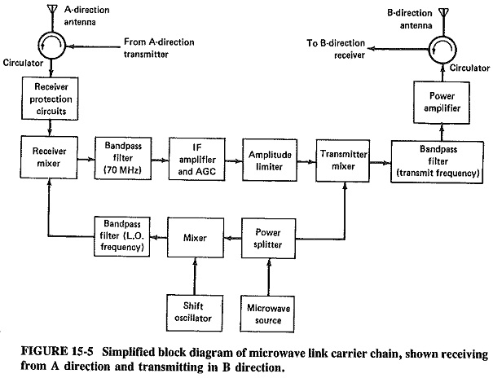Microwave communication link provide the means for the comm. System.It uses microwave range to establish the comm. Range. Fig show the above.
The basic blocks are explained below
Antenna: Mostly parabolic reflector types of antennas are used. Hog horn type of antennas are used in high density links.
Circulator: A circulator is used to isolate transmitter with the receiver input and to couple transmitter to antenna and antenna to receiver input.
Protection circuitry: It provides safety to the mixer from overloads.
Mixer: It has two outputs. One is the incomming signal (received signal) and the other is the signal from lower band pass filter. This signal has a frequency which is 70 Mhz higher than that of the incoming signal.so, mixer gives an IF signal of 70 MHz.
Band pass filter: It provides the necessary selectivity to the receiver.
IF amplifier and AGC: It is responsible for the amplification of the signal. It has many stages and its gain is controlled through AGC. It has to be linear broad band and low noise amplifier.
Amplitude limiter: As the signal is frequency modulated one so an amplitude limiter is used to avoid unwanted amplitude variations.
Mixer(Transmitter): It is used to convert IF frequency to transmitting microwave frequency. Generally varactor diodes are employs in this mixer.
Band pass filter: This allows only the signal within the desired freq. band to pass through it and hence prevents interference.
Power amplifier: Transmitted power from a repeater station can be in the range of 0.25 W to 10 W. when the required transmitter power is in the range of 1 to 5W and the freq. below 6GHZ, FET power amplifiers are generally used. When the power is above 5W and the freq. above 6GHZ , TW Ts are used for power amplification
Microwave source: VHF transitter crystal oscillator used with a varactor amplifier .
Power splitter: It divides output power from microwave source and feeds to transmitter mixer which converts it to transmitting microwave freq. the 2nd postion fed to the balance mixer
Shift oscillator: It provide input to the balanced mixer such that output freq. from balance mixer produce 70 MHz IF at output or receiver mixer.
A microwave link incorporates 600 to 2700 channel per carrier
No. of carrier in each direction can be 4 to 12
Towers erected by mobile company are the example of microwave repeater station.

Troposcatter Communication-basic idea:
Troposcatter Communications are used for beyond line of sight (over the horizon) point to point communications between remote geographic areas where cable links are not feasible.
this technology uses particles that make up the lower portion of the earth’s atmosphere (Troposphere) as a reflector for microwave radio signals. In troposcatter propagation, when a signal is aimed towards the troposphere, some part of the radio signal is scattered back to the Earth due to forward scattering in the troposphere. This returning signal is received by a receiver at the other end. But in troposcatter propagation, only a small portion of the signal is scattered forward and reaches the receiver, a major part of the signal is either lost in space or reflects in other directions.
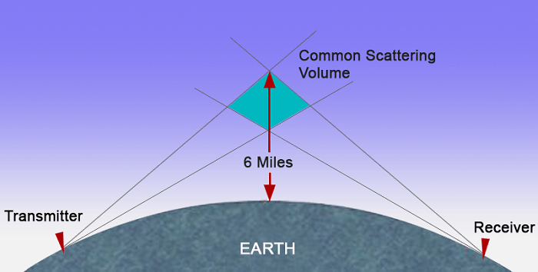
A troposcatter system has an antenna at both ends, capable of both transmitting and receiving signals, aimed at a fixed point in the troposphere slightly above the horizon. The common region where the antenna beams intersect is the area where the forward scattering phenomenon takes place.

Tropospheric scatter (also known as troposcatter) is a method of communicating with microwave radio signals over considerable distances – often up to 300 kilometres (190 mi), and further depending on terrain and climate factors. This method of propagation uses the tropospheric scatter phenomenon, where radio waves at UHF and SHF frequencies are randomly scattered as they pass through the upper layers of the troposphere. Radio signals are transmitted in a narrow beam aimed just above the horizon in the direction of the receiver station. As the signals pass through the troposphere, some of the energy is scattered back toward the Earth, allowing the receiver station to pick up the signal.^{[1]}
Normally, signals in the microwave frequency range travel in straight lines, and so are limited to line of sight applications, in which the receiver can be 'seen' by the transmitter. Communication distances are limited by the visual horizon to around 30–40 miles (48–64 km). Troposcatter allows microwave communication beyond the horizon. It was developed in the 1950s and used for military communications until communications satellites largely replaced it in the 1970s.
Because the troposphere is turbulent and has a high proportion of moisture the tropospheric scatter radio signals are refracted and consequently only a tiny proportion of the radio energy is collected by the receiving antennas. Frequencies of transmission around 2 GHz are best suited for tropospheric scatter systems as at this frequency the wavelength of the signal interacts well with the moist, turbulent areas of the troposphere, improving signal to noise ratio

Chapter 6

Radar Systems

- Introduction to radar, its various applications, radar range equation (no derivation) and its applications.
- Block diagram and operating principles of basic pulse radar. Concepts of ambiguous range, radar area of cross-section and its dependence on frequency.
- Block diagram and operating principles of CW (Doppler) and FMCW radars, and their applications.
- Block diagram and operating principles of MTI radar.
Radar display- PPI

Introduction to radar:
Basic Radar system:
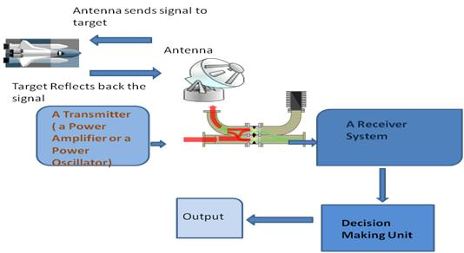
RADAR stands for Radio Detection and Ranging System. It is basically an electromagnetic system used to detect the location and distance of an object from the point where the RADAR is placed. It works by radiating energy into space and monitoring the echo or reflected signal from the objects. It operates in the UHF and microwave range.
The RADAR system generally consists of a transmitter which produces an electromagnetic signal which is radiated into space by an antenna. When this signal strikes any object, it gets reflected or reradiated in many directions. This reflected or echo signal is received by the radar antenna which delivers it to the receiver, where it is processed to determine the geographical statistics of the object. The range is determined by the calculating the time taken by the signal to travel from the RADAR to the target and back. The target’s location is measured in angle, from the direction of maximum amplitude echo signal, the antenna points to. To measure range and location of moving objects, Doppler Effect is used.

Radar types:
- Pulse Doppler radar
- Moving Target Indicator RADAR
- Continuous Wave RADAR

RADAR Applications:
Military Applications:
The RADAR has 3 major applications in Military:
- In air defense it is used for target detection, target recognition and weapon control (directing the weapon to the tracked targets).
- In missile system to guide the weapon.
- Identifying enemy locations in map.
Air Traffic Control:
The RADAR has 3 major applications in Air Traffic control:
- To control air traffic near airports. The Air Surveillance RADAR is used to detect and display the aircraft’s position in the airport terminals.
- To guide the aircraft to land in bad weather using Precision Approach RADAR.
- To scan the airport surface for aircraft and ground vehicle positions
Remote Sensing: RADAR can be used for observing weather or observing planetary positions and monitoring sea ice to ensure smooth route for ships.
Ground Traffic Control: RADAR can also be used by traffic police to determine speed of the vehicle, controlling the movement of vehicles by giving warnings about presence of other vehicles or any other obstacles behind them.
Space:
RADAR has 3 major applications:
- To guide the space vehicle for safe landing on moon
- To observe the planetary systems
- To detect and track satellites
- To monitor the meteors
Radar range equation:
Radar range equation is helpful in understanding the radar operation and it also helpful in determine the max. distance of target from the radar
There exist hundreds of versions of the radar range equation. Below is one of the more basic forms for a single antenna system (same antenna for both transmit and receive). The target is assumed to be in the center of the antenna beam. The maximum radar detection range is;
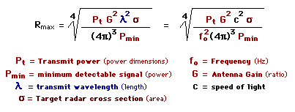
The variables in the above equation are constant and radar dependent except target RCS. Transmit power will be on the order of 1 mW (0 dBm) and antenna gain around 100 (20 dB) for an effective radiated power (ERP) of 100 mW (20 dBm). Minimum detectable signals are on the order of picowatts; RCS for an automobile might be on the order of 100 square meters. The accuracy of the radar range equation is only as good as the input data.
Minimum detectable signal (P_{min}) depends on receiver bandwidth (B), noise figure (F), temperature (T), and required signal-to-noise ratio (S/N). A narrow bandwidth receiver will be more sensitive than a wider bandwidth receiver. Noise figure is a measure of how much noise a device (the receiver) contributes to a signal: the smaller the noise figure, the less noise the device contributes. Increasing temperature affects receiver sensitivity by increasing input noise.
P_{min} = k T B F (S/N)_{min}
P_{min} = Minimum Detectable Signal
k = Blotzmann's Constant = 1.38 x 10⁻²³ (Watt*sec/°Kelvin)
T = Temperature (°Kelvin)
B = Receiver Bandwidth (Hz)
F = Noise Factor (ratio), Noise Figure (dB)
(S/N)_{min} = Minimum Signal to Noise Ratio
The available input thermal noise power (background noise) is proportional to the product kTB where k is Boltzmann's constant, T is temperature (degrees Kelvin) and B is receiver noise bandwidth (approximately receiver bandwidth) in hertz.
T = 290°K (62.33°F), B = 1 Hz
kTB = -174 dBm/Hz
The radar range equation above can be written for power received as a function of range for a given transmit power, wavelength, antenna gain, and RCS.
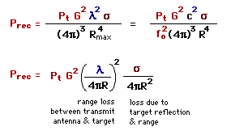
P_{rec} = Power Received  P_{t} = Transmit Power  f_{o} = Transmit Frequency  Lamda = Transmit Wavelength | G = Antenna Gain  Sigma = Radar Cross Section  R = Range  c = Speed of Light

Radar Detector Range
Radar has a range loss inversely proportional to range to the 4th power (1/R⁴). Radio communications range losses are inversely proportional to range squared (one-way path is 1/R²). Signal power received (by a radar detector), where Gdet is detector antenna gain, can be expressed as shown below. By substituting radar detector minimum signal for power received, detector maximum range can be estimated if radar power and antenna gain are known (ERP -- effective radiated power).
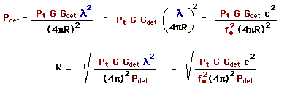
P_{det} = Power Received by Detector
G_{det} = Detector Antenna Gain
Radar propagation loss is proportional to 1/R⁴ (2-way signal path), while a radar detector would be picking up the signal on the direct (1-way) path with loss proportional to 1/R² (a hugh advantage for the detector). Another hugh advantage is the radar is receiving a reflection (RCS), most of the reflective energy is directed away from the radar. The radar has the advantage of a much larger antenna (more gain) and more sensitive (to radar signal) receiver. However, good radar detector should be able to detect a radar before the radar detects the vehicle, but not always.
Block diagram and operating principles of basic pulse radar.
The Radar, which operates with pulse signal for detecting stationary targets is called Basic Pulse Radar or simply, Pulse Radar. In this chapter, let us discuss the working of Pulse Radar.

Block Diagram of Pulse Radar
Pulse Radar uses single Antenna for both transmitting and receiving of signals with the help of Duplexer. Following is the block diagram of Pulse Radar −
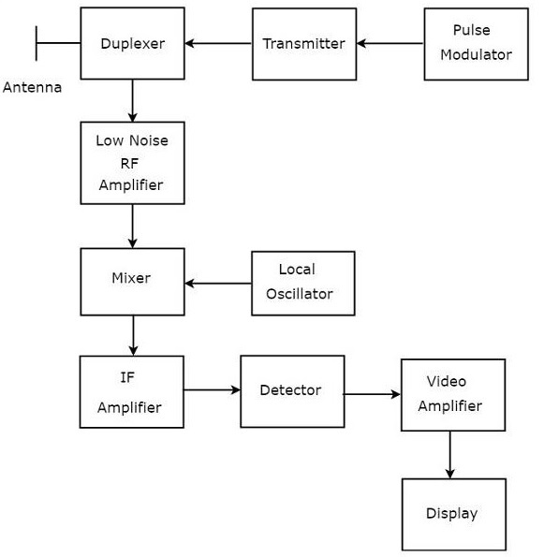
Let us now see the function of each block of Pulse Radar −
- Pulse Modulator − It produces a pulse-modulated signal and it is applied to the Transmitter.
- Transmitter − It transmits the pulse-modulated signal, which is a train of repetitive pulses.
- Duplexer − It is a microwave switch, which connects the Antenna to both transmitter section and receiver section alternately. Antenna transmits the pulse-modulated signal, when the duplexer connects the Antenna to the transmitter. Similarly, the signal, which is received by Antenna will be given to Low Noise RF Amplifier, when the duplexer connects the Antenna to Low Noise RF Amplifier.
- Low Noise RF Amplifier − It amplifies the weak RF signal, which is received by Antenna. The output of this amplifier is connected to Mixer.
- Local Oscillator − It produces a signal having stable frequency. The output of Local Oscillator is connected to Mixer.
- Mixer − We know that Mixer can produce both sum and difference of the frequencies that are applied to it. Among which, the difference of the frequencies will be of Intermediate Frequency (IF) type.
- IF Amplifier − IF amplifier amplifies the Intermediate Frequency (IF) signal. The IF amplifier shown in the figure allows only the Intermediate Frequency, which is obtained from Mixer and amplifies it. It improves the Signal to Noise Ratio at output.
- Detector − It demodulates the signal, which is obtained at the output of the IF Amplifier.
- Video Amplifier − As the name suggests, it amplifies the video signal, which is obtained at the output of detector.
- Display − In general, it displays the amplified video signal on CRT screen.
Concepts of ambiguous range

Range ambiguity resolution is a technique used with medium Pulse repetition frequency (PRF) radar to obtain range information for distances that exceed the distance between transmit pulses.
This signal processing technique is required with pulse-Doppler radar.^{[1][2][3]}
The raw return signal from a reflection will appear to be arriving from a distance less than the true range of the reflection when the wavelength of the pulse repetition frequency (PRF) is less than the range of the reflection. This causes reflected signals to be folded, so that the apparent range is a modulo function of true range.
Range aliasing occurs when reflections arrive from distances that exceed the distance between transmit pulses at a specific pulse repetition frequency (PRF).
Range ambiguity resolution is required to obtain the true range when the measurements are made using a system where the following inequality is true.

Here c is the signal speed, which for radar is the speed of light. The range measurements made in this way produces a modulo function of the true range.

Theory

Limitations
This technique has two limitations.
- Blind Zones
- Multiple Targets
The process described above is slightly more complex in real systems because more than one detection signal can occur within the radar beam. The pulse rate must alternate rapidly between at least 4 different PRF to handle these complexities.
Radar area of cross section and dependence on freq.
radar cross-section σ is a specific parameter of a reflective object that depends on many factors, and which has units of m². The calculation of the radar cross-section is only possible for simple objects. The surface area of simple geometric bodies depends on the shape of the body and the wavelength, or rather on the ratio of the structural dimensions of the object to the wavelength. If absolutely all of the incident radar energy on the target were reflected equally in all directions, then the radar cross-section would be equal to the target's cross-sectional area as seen by the transmitter. In practice, some energy is absorbed and the reflected energy is not distributed equally in all directions. Therefore, the radar cross-section is quite difficult to estimate and is normally determined by measurement.
The target radar cross-sectional area depends of:
- the airplane’s physical geometry and exterior features,
- the direction of the illuminating radar,
- the radar transmitters frequency,
- the used material types.
The use of stealth technology to reduce radar cross-section increases the survivability and decreases the target detection of military aircraft. But the stealth technology depends of the used radar transmitters frequency and has none effect against VHF- radars like P–12 or P-18, both used by serbian air defense units during the Kosovo war.

Calculation of the radar cross-section
Radar cross-section (RCS) is the measure of a target's ability to reflect radar signals in the direction of the radar receiver, i.e. it is a measure of the ratio of backscatter density in the direction of the radar (from the target) to the power density that is intercepted by the target. Since the power is distributed on the shape of a sphere, a small part of this (4·π·r²) can be received by the radar.
Radar cross-section σ is as defined as:
σ = | 4·π·r²·S_{r} | mit | σ: measure of the target's ability to reflect radar signals in direction of the radar receiver, in [m²]  S_{t}: power density that is intercepted by the target, in [W/m²]  S_{r}: scattered power density in the range r, in [W/m²] | (1)
 | S_{t}
The RCS of a target can be viewed as a comparison of the strength of the reflected signal from a target to the reflected signal from a perfectly smooth sphere of cross-sectional area of 1 m².
The following backscattering formulas from shapes occurs in an optical independent of frequency region.
reflected signal from a spherical shape | σ_{max} = π ·R² (2)
reflected signal from a cylinder | σ_{max} = 2·π·r·h² (3)  λ
reflected signal from a flat plate | σ_{max} = 4·π·b²·h² (4)  λ²
reflected signal from a tilted plate | ...Real as the previous example. Unusual feature: the reflected energy is reflected in another direction. Well, the transmitting radar cannot receive this energy. Therefore there are bistatic radars at which the transmitter and the receivers are separated from each other spatially.
Table 1: RCS for geometrically bodies

RCS for Point-Like Targets
Targets | RCS [m²] | RCS [dB]
Bird | 0.01 | -20
Man | 1 | 0
cabin cruiser | 10 | 10
Automobile | 100 | 20
Truck | 200 | 23
corner reflector | 20379 | 43.1
Table 2: RCS for Point-Like Targets
Some targets have large values of RCS owing to their size and orientation and consequently, reflect a large portion of the incident power. The beside table shows the values of RCS for some targets at X-Band
(Table from: M. Skolnik, “Introduction to radar systems”, 2nd Edition, McGraw-Hill, Inc 1980, page 44.
The RCS of the corner reflector is given for a triangular reflector with a length of 1.5 m.)

CW (Doppler) radar:
basic Radar uses the same Antenna for both transmission and reception of signals. We can use this type of Radar, when the target is stationary, i.e., not moving and / or when that Radar can be operated with pulse signal.
The Radar, which operates with continuous signal (wave) for detecting non-stationary targets, is called Continuous Wave Radar or simply CW Radar. This Radar requires two Antennas. Among which, one Antenna is used for transmitting the signal and the other Antenna is used for receiving the signal.

Block Diagram of CW Radar
We know that CW Doppler Radar contains two Antennas − transmitting Antenna and receiving Antenna. Following figure shows the block diagram of CW Radar −
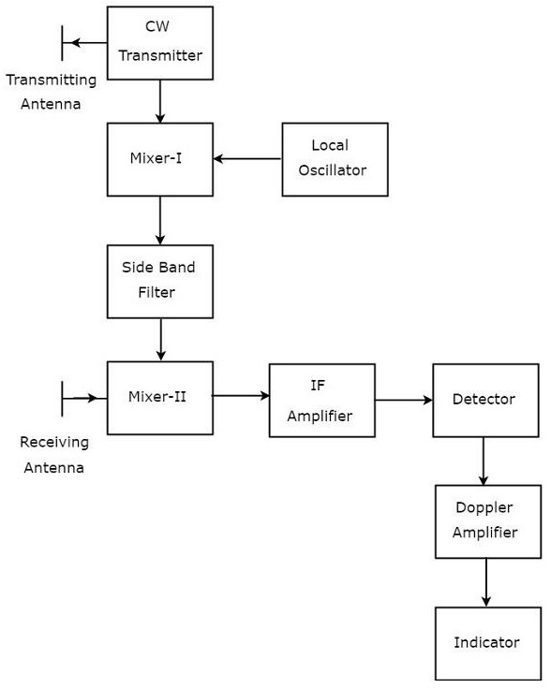
The block diagram of CW Doppler Radar contains a set of blocks and the function of each block is mentioned below.
- CW Transmitter − It produces an analog signal having a frequency of fo
• . The output of CW Transmitter is connected to both transmitting Antenna and Mixer-I.
• Local Oscillator − It produces a signal having a frequency of fl
• . The output of Local Oscillator is connected to Mixer-I.
• Mixer-I − Mixer can produce both sum and difference of the frequencies that are applied to it. The signals having frequencies of fo
and fl are applied to Mixer-I. So, the Mixer-I will produce the output having frequencies fo+fl or fo−fl
• .
• Side Band Filter − As the name suggests, side band filter allows a particular side band frequencies − either upper side band frequencies or lower side band frequencies. The side band filter shown in the above figure produces only upper side band frequency, i.e., fo+fl
• .
• Mixer-II − Mixer can produce both sum and difference of the frequencies that are applied to it. The signals having frequencies of fo+fl
and fo±fd are applied to Mixer-II. So, the Mixer-II will produce the output having frequencies of 2fo+fl±fd or fl±fd
• .
• IF Amplifier − IF amplifier amplifies the Intermediate Frequency (IF) signal. The IF amplifier shown in the figure allows only the Intermediate Frequency, fl±fd
• and amplifies it.
• Detector − It detects the signal, which is having Doppler frequency, fd
• .
• Doppler Amplifier − As the name suggests, Doppler amplifier amplifies the signal, which is having Doppler frequency, fd
- .
- Indicator − It indicates the information related relative velocity and whether the target is inbound or outbound.
CW Doppler Radars give accurate measurement of relative velocities. Hence, these are used mostly, where the information of velocity is more important than the actual range.

FMCW:
If CW Doppler Radar uses the Frequency Modulation, then that Radar is called FMCW Doppler Radar or simply, FMCW Radar. It is also called Continuous Wave Frequency Modulated Radar or CWFM Radar. It measures not only the speed of the target but also the distance of the target from the Radar.

Block Diagram of FMCW Radar
FMCW Radar is mostly used as Radar Altimeter in order to measure the exact height while landing the aircraft. The following figure shows the block diagram of FMCW Radar −
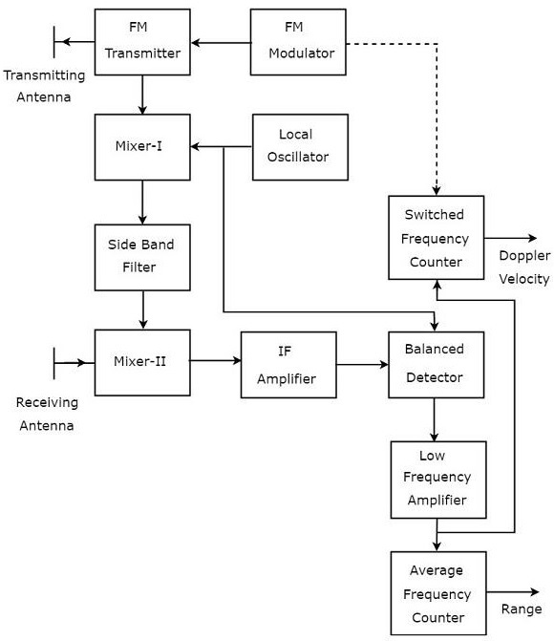
FMCW Radar contains two Antennas − transmitting Antenna and receiving Antenna as shown in the figure. The transmitting Antenna transmits the signal and the receiving Antenna receives the echo signal.
The block diagram of the FMCW Radar looks similar to the block diagram of CW Radar. It contains few modified blocks and some other blocks in addition to the blocks that are present in the block diagram of CW Radar. The function of each block of FMCW Radar is mentioned below.
- FM Modulator − It produces a Frequency Modulated (FM) signal having variable frequency, fo(t)
• and it is applied to the FM transmitter.
• FM Transmitter − It transmits the FM signal with the help of transmitting Antenna. The output of FM Transmitter is also connected to Mixer-I.
• Local Oscillator − In general, Local Oscillator is used to produce an RF signal. But, here it is used to produce a signal having an Intermediate Frequency, fIF
• . The output of Local Oscillator is connected to both Mixer-I and Balanced Detector.
• Mixer-I − Mixer can produce both sum and difference of the frequencies that are applied to it. The signals having frequencies of fo(t)
and fIF are applied to Mixer-I. So, the Mixer-I will produce the output having frequency either fo(t)+fIF or fo(t)−fIF
• .
• Side Band Filter − It allows only one side band frequencies, i.e., either upper side band frequencies or lower side band frequencies. The side band filter shown in the figure produces only lower side band frequency. i.e., fo(t)−fIF
• .
• Mixer-II − Mixer can produce both sum and difference of the frequencies that are applied to it. The signals having frequencies of fo(t)−fIF
and fo(t−T) are applied to Mixer-II. So, the Mixer-II will produce the output having frequency either fo(t−T)+fo(t)−fIF or fo(t−T)−fo(t)+fIF
• .
• IF Amplifier − IF amplifier amplifies the Intermediate Frequency (IF) signal. The IF amplifier shown in the figure amplifies the signal having frequency of fo(t−T)−fo(t)+fIF
• . This amplified signal is applied as an input to the Balanced detector.
• Balanced Detector − It is used to produce the output signal having frequency of fo(t−T)−fo(t)
from the applied two input signals, which are having frequencies of fo(t−T)−fo(t)+fIF and fIF
• . The output of Balanced detector is applied as an input to Low Frequency Amplifier.
• Low Frequency Amplifier − It amplifies the output of Balanced detector to the required level. The output of Low Frequency Amplifier is applied to both switched frequency counter and average frequency counter.
• Switched Frequency Counter − It is useful for getting the value of Doppler velocity.
• Average Frequency Counter − It is useful for getting the value of Range.
MTI radar:
If the Radar is used for detecting the movable target, then the Radar should receive only the echo signal due to that movable target. This echo signal is the desired one. However, in practical applications, Radar receives the echo signals due to stationary objects in addition to the echo signal due to that movable target.
The echo signals due to stationary objects (places) such as land and sea are called clutters because these are unwanted signals. Therefore, we have to choose the Radar in such a way that it considers only the echo signal due to movable target but not the clutters.
For this purpose, Radar uses the principle of Doppler Effect for distinguishing the non-stationary targets from stationary objects. This type of Radar is called Moving Target Indicator Radar or simply, MTI Radar.
According to Doppler effect, the frequency of the received signal will increase if the target is moving towards the direction of Radar. Similarly, the frequency of the received signal will decrease if the target is moving away from the Radar.

Types of MTI Radars
We can classify the MTI Radars into the following two types based on the type of transmitter that has been used.
- MTI Radar with Power Amplifier Transmitter
- MTI Radar with Power Oscillator Transmitter
Now, let us discuss about these two MTI Radars one by one.

MTI Radar with Power Amplifier Transmitter
MTI Radar uses single Antenna for both transmission and reception of signals with the help of Duplexer. The block diagram of MTI Radar with power amplifier transmitter is shown in the following figure.
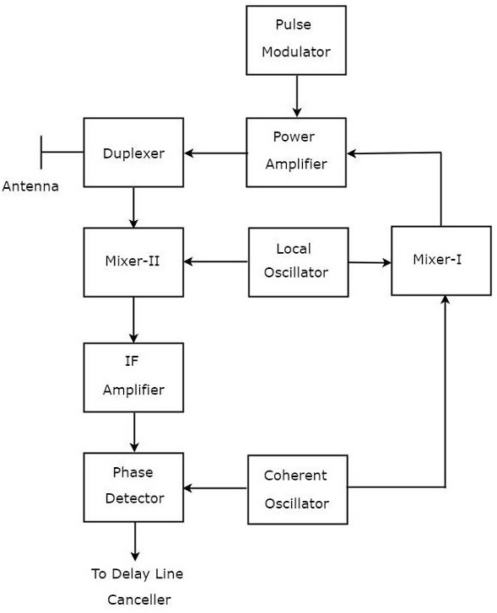
The function of each block of MTI Radar with power amplifier transmitter is mentioned below.
- Pulse Modulator − It produces a pulse modulated signal and it is applied to Power Amplifier.
- Power Amplifier − It amplifies the power levels of the pulse modulated signal.
- Local Oscillator − It produces a signal having stable frequency fl
• . Hence, it is also called stable Local Oscillator. The output of Local Oscillator is applied to both Mixer-I and Mixer-II.
• Coherent Oscillator − It produces a signal having an Intermediate Frequency, fc
• . This signal is used as the reference signal. The output of Coherent Oscillator is applied to both Mixer-I and Phase Detector.
• Mixer-I − Mixer can produce either sum or difference of the frequencies that are applied to it. The signals having frequencies of fl
and fc are applied to Mixer-I. Here, the Mixer-I is used for producing the output, which is having the frequency fl+fc
• .
• Duplexer − It is a microwave switch, which connects the Antenna to either the transmitter section or the receiver section based on the requirement. Antenna transmits the signal having frequency fl+fc
when the duplexer connects the Antenna to power amplifier. Similarly, Antenna receives the signal having frequency of fl+fc±fd
• when the duplexer connects the Antenna to Mixer-II.
• Mixer-II − Mixer can produce either sum or difference of the frequencies that are applied to it. The signals having frequencies fl+fc±fd
and fl are applied to Mixer-II. Here, the Mixer-II is used for producing the output, which is having the frequency fc±fd
• .
• IF Amplifier − IF amplifier amplifies the Intermediate Frequency (IF) signal. The IF amplifier shown in the figure amplifies the signal having frequency fc+fd
- . This amplified signal is applied as an input to Phase detector.
Phase Detector − It is used to produce the output signal having frequency fd
from the applied two input signals, which are having the frequencies of fc+fd and fc
. The output of phase detector can be connected to Delay line canceller.

MTI Radar with Power Oscillator Transmitter
The block diagram of MTI Radar with power oscillator transmitter looks similar to the block diagram of MTI Radar with power amplifier transmitter. The blocks corresponding to the receiver section will be same in both the block diagrams. Whereas, the blocks corresponding to the transmitter section may differ in both the block diagrams.
The block diagram of MTI Radar with power oscillator transmitter is shown in the following figure.
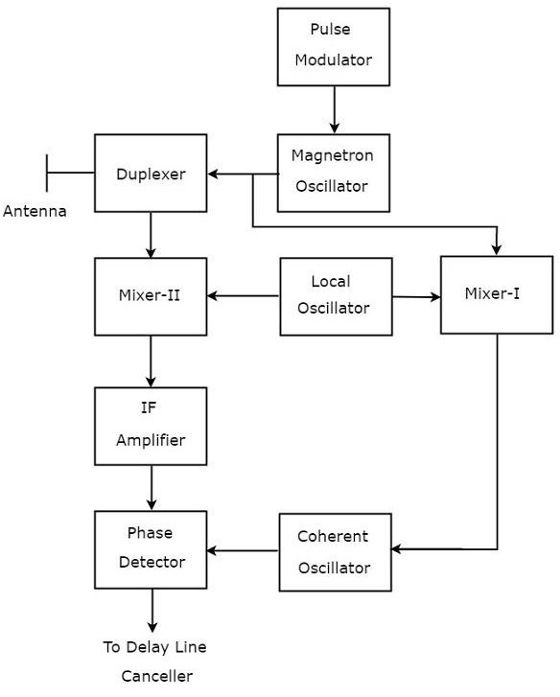
As shown in the figure, MTI Radar uses the single Antenna for both transmission and reception of signals with the help of Duplexer. The operation of MTI Radar with power oscillator transmitter is mentioned below.
- The output of Magnetron Oscillator and the output of Local Oscillator are applied to Mixer-I. This will further produce an IF signal, the phase of which is directly related to the phase of the transmitted signal.
- The output of Mixer-I is applied to the Coherent Oscillator. Therefore, the phase of Coherent Oscillator output will be locked to the phase of IF signal. This means, the phase of Coherent Oscillator output will also directly relate to the phase of the transmitted signal.
- So, the output of Coherent Oscillator can be used as reference signal for comparing the received echo signal with the corresponding transmitted signal using phase detector.
Radar display PPI:
An electronic instrument, which is used for displaying the data visually is known as display. So, the electronic instrument which displays the information about Radar’s target visually is known as Radar display. It shows the echo signal information visually on the screen.

Types of Radar Displays
In this section, we will learn about the different types of Radar Displays. The Radar Displays can be classified into the following types.

A-Scope
It is a two dimensional Radar display. The horizontal and vertical coordinates represent the range and echo amplitude of the target respectively. In A-Scope, the deflection modulation takes place. It is more suitable for manually tracking Radar.

B-Scope
It is a two dimensional Radar display. The horizontal and vertical coordinates represent the azimuth angle and the range of the target respectively. In B-Scope, intensity modulation takes place. It is more suitable for military Radars.

C-Scope
It is a two-dimensional Radar display. The horizontal and vertical coordinates represent the azimuth angle and elevation angle respectively. In C-Scope, intensity modulation takes place.

D-Scope
If the electron beam is deflected or the intensity-modulated spot appears on the Radar display due to the presence of target, then it is known as blip. C-Scope becomes D-Scope, when the blips extend vertically in order to provide the distance.

E-Scope
It is a two-dimensional Radar display. The horizontal and vertical coordinates represent the distance and elevation angle respectively. In E-Scope, intensity modulation takes place.

F-Scope
If the Radar Antenna is aimed at the target, then F-Scope displays the target as a centralized blip. So, the horizontal and vertical displacements of the blip represent the horizontal and vertical aiming errors respectively.

G-Scope
If the Radar Antenna is aimed at the target, then G-Scope displays the target as laterally centralized blip. The horizontal and vertical displacements of the blip represent the horizontal and vertical aiming errors respectively.

H-Scope
It is the modified version of B-Scope in order to provide the information about elevation angle of the target. It displays the target as two blips, which are closely spaced. This can be approximated to a short bright line and the slope of this line will be proportional to the sine of the elevation angle.

I-Scope
If the Radar Antenna is aimed at the target, then I-Scope displays the target as a circle. The radius of this circle will be proportional to the distance of the target. If the Radar Antenna is aimed at the target incorrectly, then I-Scope displays the target as a segment instead of circle. The arc length of that segment will be inversely proportional to the magnitude of pointing error.

J-Scope
It is the modified version of A-Scope. It displays the target as radial deflection from time base.

K-Scope
It is the modified version of A-Scope. If the Radar Antenna is aimed at the target, then K-Scope displays the target as a pair of vertical deflections, which are having equal height. If the Radar Antenna is aimed at the target incorrectly, then there will be pointing error. So, the magnitude and the direction of the pointing error depends on the difference between the two vertical deflections.

L-Scope
If the Radar Antenna is aimed at the target, then L-Scope displays the target as two horizontal blips having equal amplitude. One horizontal blip lies to the right of central vertical time base and the other one lies to the left of central vertical time base.

M-Scope
It is the modified version of A-Scope. An adjustable pedestal signal has to be moved along the baseline till it coincides the signal deflections, which are coming from the horizontal position of the target. In this way, the target’s distance can be determined.

N-Scope
It is the modified version of K-Scope. An adjustable pedestal signal is used for measuring distance.

O-Scope
It is the modified version of A-Scope. We will get O-Scope, by including an adjustable notch to A-Scope for measuring distance.

P-Scope
It is a Radar display, which uses intensity modulation. It displays the information of echo signal as plan view. Range and azimuth angle are displayed in polar coordinates. Hence, it is called the Plan Position Indicator or the PPI display.

R-Scope
It is a Radar display, which uses intensity modulation. The horizontal and vertical coordinates represent the range and height of the target respectively. Hence, it is called Range-Height Indicator or RHI display.

